Report: Many In "Black Rural South" Lack Broadband
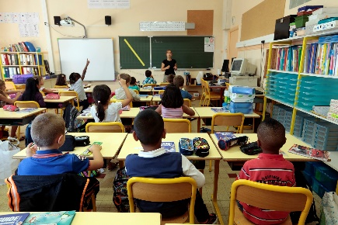
The Joint Center for Political and Economic Studies reports that 38% of residents in what it calls the "Black Rural South" lack high-speed internet access, compared to a fifth of the total US. Federal infrastructure and recovery programs should prioritize the area, which the Joint Center defines as 152 counties across 10 states where Black people make up at least 35% of the population, Center experts advise.
Telecompetitor 7/26/21
https://www.telecompetitor.com/report-black-rural-south-less-likely-to-have-broadband-access/
Image credit:
https://www.bing.com/images/search?view=detailV2&ccid=XaXqjxUW&id=8A6311D27A6C50DFF47AF3B233BABE0ADA2A3154&thid=OIP.XaXqjxUWp_NltpKVYdlAPAHaE8&mediaurl=https%3a%2f%2fwww.brookings.edu%2fwp-content%2fuploads%2f2016%2f12%2fstudent_classroom_003.jpg&cdnurl=https%3a%2f%2fth.bing.com%2fth%2fid%2fR.5da5ea8f1516a7f365b6929561d9403c%3frik%3dVDEq2gq%252bujOy8w%26pid%3dImgRaw&exph=1138&expw=1707&q=Education+in+America&simid=608043553925696762&FORM=IRPRST&ck=44463B3BCFB609E0A71A68802550376A&selectedIndex=16&ajaxhist=0&ajaxserp=0

