Report Details Hidden Fees Applied by Cable Companies
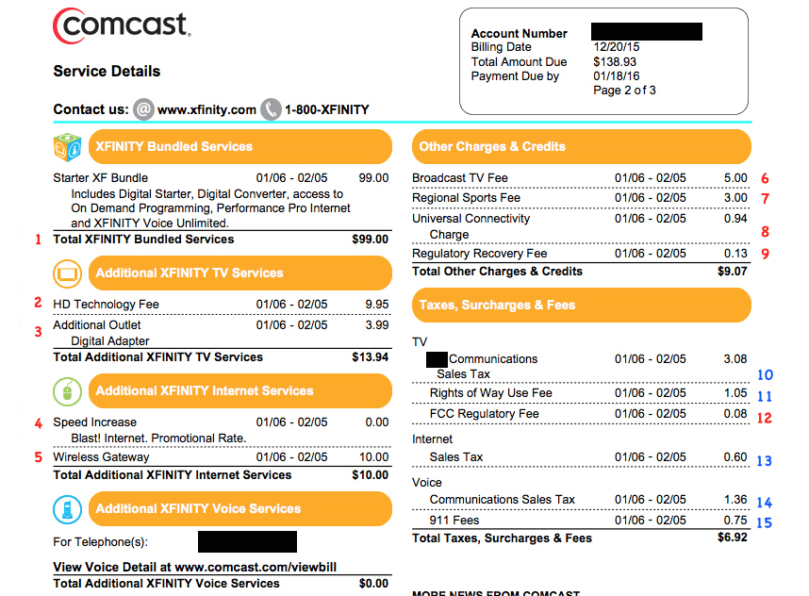
Hidden fees that cable companies levy on consumers on top of the advertised subscription costs can increase charges by $450 annually, Consumer Reports says after examining close to 800 statements. The extra charges, which can include fees for regional sports, HD technology and network access, are not mandated by the government or broadcasters, the company notes.
USA Today 10/3/19
https://www.usatoday.com/story/tech/2019/10/03/consumer-reports-cable-tv-add-fees-can-cost-you-450-yearly/3842661002/
Image credit:
https://article.images.consumerreports.org/prod/content/dam/consumerist/2016/01/comcastbillmarkedup1.png

