Report: Mobile Offers Increase Brand Loyalty
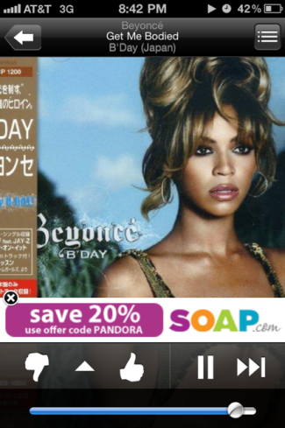
More than three-quarters -- 77% -- of consumers say that receiving mobile offers like exclusive content, surprise points or birthday greetings make them feel more loyal to a brand, Vibes reports. Just under 60% said they would like to receive order updates via text.
CMO (Australia) 1/22/16
http://www.cmo.com.au/article/592631/report-mobile-based-campaigns-coupons-boost-consumer-brand-sentiment/

