Journalist Fatally Shot While Covering Other Shooting Death
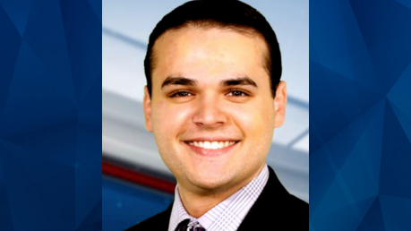
Journalists from Florida's Spectrum News 13 were shot while the crew was covering another fatal shooting, in what the National Association of Broadcasters says is "a reminder of the risks that members of the press face in their efforts to inform the public." One journalist died and another is in critical condition; the suspect also allegedly killed an unrelated woman and a nine-year-old, leaving the child's mother in critical condition as well.
Axios 2/22/23
https://www.axios.com/2023/02/23/florida-tv-journalist-killed-covering-orange-county-shooting
Image credit:
https://co-a2.freetls.fastly.net/co-uploads/2021/07/Dylan-Lyons-.jpg

