Reporter Zero, a film by Carrie Lozano, is the story of maverick journalist Randy Shilts and his groundbreaking coverage of the AIDS crisis.
There is a customary belief (a practice of what is proper) in the news industry that you should not report on stories that you are directly involved in. Randy Shilts was involved in the story he covered and was criticized by some as being too close to the unfolding AIDS crisis in San Francisco during the 1980s.
This is an exercise in ethical decision-making. Specifically, this is to determine your position on the issue. You must use the Potter’s Box to complete the assignment. Read your class text for detailed instructions on using the Potter’s Box.

Using the Potter’s box you first provide extensive details to define the situation. For this assignment it concerns Randy Shilts and his groundbreaking coverage of the AIDS crisis. Take notes from the class discussion of the “definition” to include in your report.

Second, define and discuss the values. These values are found in the Society of Professional Journalists code, reprinted in your book and available online at https://www.spj.org/. You must use between 3 – 4 values in your response. You can also consult with other appropriate news codes but if you do you must identify them in the report. It is important that your answer recognizes his abiding by and violating the SPJ code.

Third, identify and discuss the appropriate principles that you believe are important to this matter. The book reprints information on the ethical principles. You must use between 2 – 3 principles. It is important that your answer recognizes his abiding by and violating the ethical principles.

Fourth, identify and explain the loyalties Shilts had to consider in his effort to cover the AIDS crisis in San Francisco. You will need to identify and explain at least 3 loyalties but 5 would be an effort toward an outstanding answer.

Once you complete all four parts of the Potter’s Box you can now answer the two questions with your statement on the issue.

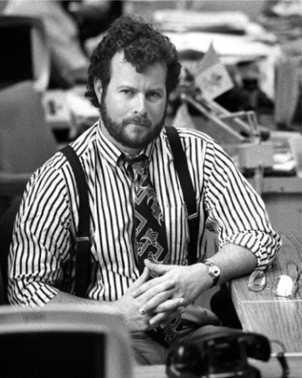

Image credit: http://www.reporterzero.com/images/reporter_zero_shilts.jpg

Continued….

The two questions to answer:

1 - Was it acceptable for Randy Shilts, who was gay and HIV positive, to be reporting on the story?

2 - Did he have a responsibility to reveal this to the readers?

The answers must be comprehensive. Your answers must be based from the appropriate points raised from your discussion of the values, principles and loyalties. Your answer becomes not just an opinion but a perspective that is based on well-thought out responses. Your answer is a balanced perspective; an answer that does not merely confirm your position.

There are web resources you can review to do additional research. They include:

Randy Shilts
https://en.wikipedia.org/wiki/Randy_Shilts

More information on Reporter Zero is available at
https://www.newday.com/film/reporter-zero

Randy Shilts Award for LGBTQ Coverage
http://www.nlgja.org/randy-shilts-award-for-lgbt-coverage/

And The Band Played On (book)
https://en.wikipedia.org/wiki/And_the_Band_Played_On

Report layout:
Cover page title is “Reporter Zero-Ethical Decision Making” and include your name and date.

Report content:
Write 2-4 paragraphs per section.
- Definition
- Values
- Loyalties
- Principles
- Statement

Double-space text. Proper spelling and grammar will count toward the grade.

Create a bibliography page to reference the film by Carrie Lozano. When you reference other works when discussing the life of Randy Shilits (web site, Wikipedia, etc.) you must credit the source using end notes in MLA style. Without citations you are plagiarizing the work of others. Not a good result for your grade.

Please expect to discuss this in class – to share your responses and hear what others have decided. You will be asked to take notes and graded on the activity as part of the assignment.

The assignment is due:
___________________________

