Reporters Struggle To Cover Gaza; AI Fears Complicate Coverage
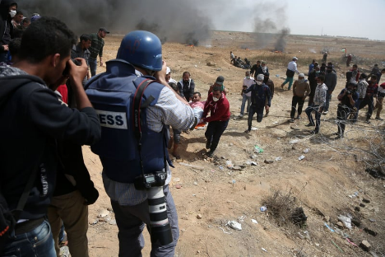
Journalists covering the ongoing conflict in Gaza are experiencing challenges as those in the region face rising threats to their physical safety while remote correspondents are harassed and pressured to take a side amid rising information surrounding the crisis. Experts say there has been relatively little AI-generated misinformation about the war, but people's fear of being misled by falsified imagery has made them less likely to believe news images are genuine.
The Hollywood Reporter 10/25/23
https://www.hollywoodreporter.com/news/politics-news/israel-media-hamas-reporting-1235626933/
Image credit:
https://electronicintifada.net/sites/default/files/styles/original_800w/public/2018-04/180426-gaza-journalists.jpg?itok=Q0MOVdsN&timestamp=1524777893

