Research: RTDNA Salary Survey – TV Up, Radio Down
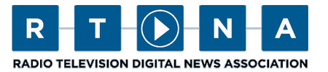
The latest RTDNA/Hofstra University Annual Survey found that local television news salaries rose by 1.9% in 2014. That's up by 0.3 from a year ago, and with inflation an extremely low 1.6%, that means that TV news salaries gained slightly in purchasing power last year. The spread of 0.3 this year at least beats the 0.1 difference a year ago.
RTDNA.org 7.13.15
http://rtdna.org/article/research_rtdna_salary_survey#.VaUuYKPbKt9

