Revlon Hires Social Media Star
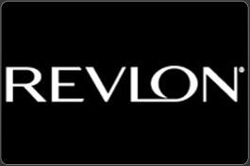
In a shift from using traditional celebrities as brand ambassadors, Revlon has teamed up with social media influencer and nail artist Chelsea King to reach new consumers in an authentic way, says Tracy Rohrbaugh, vice president of global marketing for Revlon. King will create unique content for Revlon and promote the brand through her own accounts.
Women's Wear Daily 5/19/16
http://wwd.com/beauty-industry-news/people/revlon-adds-influencer-chelsea-king-as-nail-expert-10431768/

