RIAA: Recorded Music Revenue Up for 5th Consecutive Year
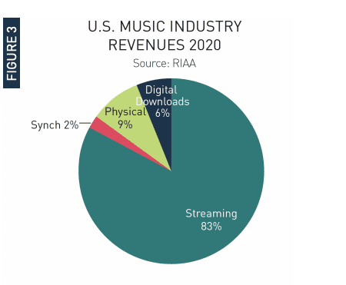
Revenue from recorded music reached $12.2 billion during 2020, marking the fifth year in a row of growth, the Recording Industry Association of America reports. A variety of streaming services contributed $10.1 billion to that figure.
Variety 2.26.21
https://variety.com/2021/music/news/riaa-report-2020-music-revenues-streaming-growth-1234916463/
Image credit:
https://musicrow.com/wp-content/uploads/2021/03/RIAA-report-2020-a.png

