Roku Calls On Nielsen To Count Viewers Across Screens
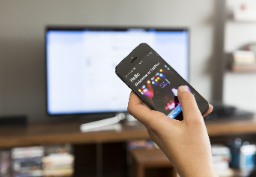
Nielsen will track viewership for streaming platform Roku across TV, computer and mobile screens under a new agreement. Reach data uses deduplicated audiences: those who don't see the same video on multiple platforms.
Variety 9.29.22
https://variety.com/2022/tv/news/nielsen-roku-measurement-cross-screen-viewership-1235387232/
Image credit:
https://theconchtech.com/wp-content/uploads/2020/02/unnamed-1.jpg

