Roku Remains Top CTV Platform
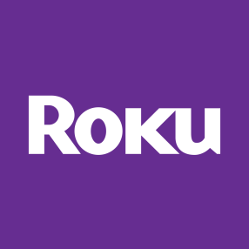
Roku was the top connected TV (CTV) platform in the US last year with 84.7 million users. Roku’s continued strength comes from selling its standalone players and TVs through major holiday events, and we expect it to capture more than half the market by 2022.
eMarketer 5.21.20
https://www.emarketer.com/content/roku-remains-top-ctv-platform-amazon-fire-tv-takes-second-spot-this-year?ecid=NL1001

