Roku To Introduce Shoppable Restaurant, Grocery Ads
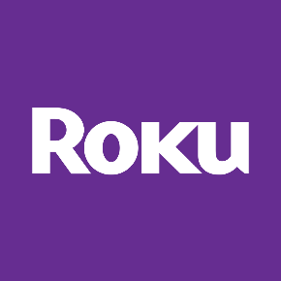
Roku will roll out shoppable ads next month that enable viewers to begin DoorDash orders through their televisions by scanning a QR code. Roku users will be offered six months of free DashPass membership, and DoorDash will be Roku's exclusive partner for the shoppable ads for a year.
Winsight Grocery Business 2.7.23
https://www.winsightgrocerybusiness.com/technology/doordash-roku-partner-food-ordering-tv

