Rubicon Project May Have a Solution for Annoying Ads
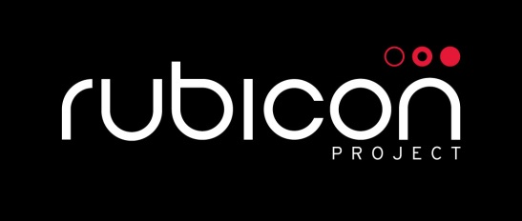
The reality is nobody likes targeted ads that aren't relevant. Marketers don't like them because they're wasting precious ad dollars and consumers don't like them for obvious reasons. Yet ad tech company Rubicon Project is trying to solve that problem -- along with several others -- through an effort aimed at making ads relevant to the consumers who see them.
Advertising Age 12.7.16
http://adage.com/article/digital/stupid-ads-rubicon-project-a-answer/307046/?utm_source=daily_email&utm_medium=newsletter&utm_campaign=adage&ttl=1481673291?utm_visit=113450

