FCC Sends $4.9B to States for Rural Broadband
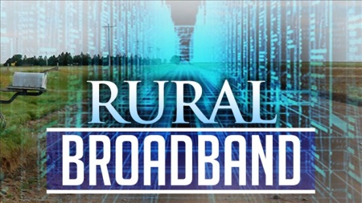
The Dakotas will benefit the most from the Federal Communications Commission's allocation of almost $5 billion to rural broadband providers in 39 states and tribal lands. Costs for rural broadband are often higher than those for access in urban areas, and the service often ends up being slower and less reliable, factors that the grants are meant to improve.
TechCrunch 8/22/19
https://techcrunch.com/2019/08/22/fcc-approves-4-9b-in-funding-for-rural-broadband-improvements/
Image credit:
https://dam.farmjournal.com/m/7477646467d3b4ce/original/Rural-Broadband.jpg

