N.Y. Public Radio Settles Labor Dispute With SAG-AFTRA
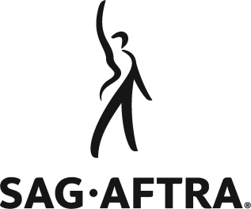
SAG-AFTRA has withdrawn union busting and retaliatory action complaints it filed against New York Public Radio after the organization dismissed two employees in 2021. The broadcaster and the union have reached a settlement deal that extends protections for on-air staff, increases compensation for employees who earn less than $100,000, expands parental leave entitlements and resolves the specific issues that prompted the complaint.
All Access Music Group 2/28/22
https://www.allaccess.com/net-news/archive/story/215998/sag-aftra-new-york-public-radio-settle-unfair-labo

