SAG-AFTRA Members Approve TV Animation Strike Authorization
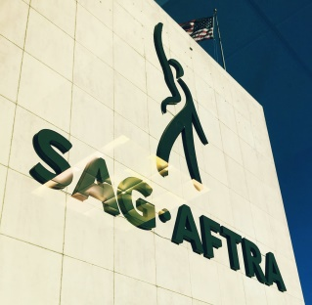
The key issue for the union is the refusal of employers to provide scale wages or residuals in the fastest-growing area of animated performer’s work — animated programs made for subscription-based streaming platforms like Netflix and Amazon. More than 75% of those voting had to approve of the strike authorization for SAG-AFTRA’s national board to call a strike.
Variety 7.18.18
https://variety.com/2018/tv/news/sag-aftra-tv-animation-strike-1202877662/
Image credit:
https://upload.wikimedia.org/wikipedia/commons/3/38/SAG_AFTRA_building.JPG

