Strike-Ending Deal Ratified By SAG-AFTRA Members
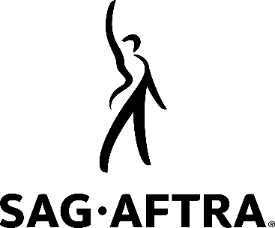
Members of the Screen Actors Guild-American Federation of Television and Radio Artists voted to ratify a three-year agreement with studios that officially ends their nearly four-month strike, with 78% in favor of ratification. The Alliance of Motion Picture and Television Producers welcomed the results, noting that ratification meant the industry could return to its full capacity.
The Associated Press 12/6/23
https://apnews.com/article/actors-strike-contract-a7a529acaf6b5b38aac93722db54c193

