Samsung Has to Pay Apple $539 Million in Patent Infringement Case
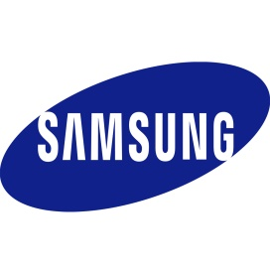
The world's top smartphone rivals have been in court over patents since 2011, when Apple filed a lawsuit alleging Samsung's smartphones and tablets "slavishly" copied its products. Samsung was found liable in a 2012 trial, but a disagreement over the amount to be paid led to the current retrial over damages.
Business Insider 5.24.18
www.businessinsider.com/samsung-apple-lawsuit-patent-infringement-2018-5

