Samsung Thinks Millennials Want Vertical TVs
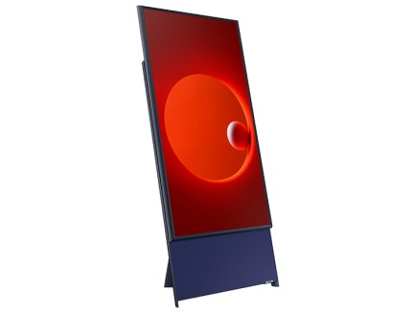
It’s a 43-inch vertical TV, a concept Samsung apparently decided to introduce as a result of our fixation with the vertical layout of mobile screens. This new TV — called the Sero, which means “vertical” in Korean — include the presence of 4.1 channel 60W speakers, plus Samsung’s digital assistant Bixby, which theoretically will let the TV also serve as anything from a music player to a super-expensive photo display.
The New York Post 5.1.19
https://nypost.com/2019/04/30/samsung-thinks-millennials-want-vertical-tvs/?utm_source=Listrak&utm_medium=Email&utm_term=Samsung+Thinks+Millennials+Want+Vertical+TVs&utm_campaign=Hearst+Aims+For+News+Transparency%2c+Relatability
Image credit:
https://sammyhub.com/wp-content/uploads/2019/04/the-sero1.jpg

