OpenAI, Microsoft Again In The Crosshairs Over Copyright
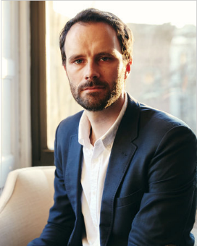
Nonfiction author Julian Sancton has filed a lawsuit against OpenAI and Microsoft, claiming the two tech companies use copyrighted materials from nonfiction and academic publications without permission to train artificial intelligence technology. The suit also claims the companies made tens of thousands of unauthorized copies of protected works to train AI systems.
The Hollywood Reporter 11.21.23
https://www.hollywoodreporter.com/business/business-news/microsoft-openai-legal-battle-authors-training-data-1235669632/
Image credit:
https://frederickcookpolar.org/wp-content/uploads/2022/02/Julian_Sancton.jpg

