Saudi Government says it Will Allow Women to Drive
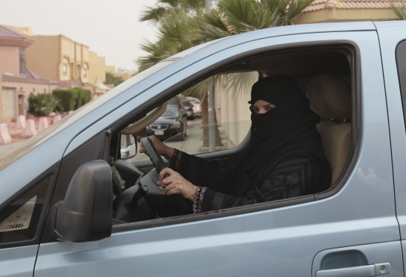
The change may be the most visible sign yet of a modernizing Saudi Arabia. Signed by King Salman, and broadcast on state television, the decree said that the “majority of senior scholars” had deemed the change legitimate under Islamic law and ordered the government ministries concerned to make whatever legal adjustments are required to implement it by June 24.
The Washington Post 9.26.17
https://www.washingtonpost.com/world/national-security/saudi-government-says-it-will-allow-women-to-drive/2017/09/26/9f1b08ea-a2ee-11e7-8cfe-d5b912fabc99_story.html?utm_term=.4db031480550&wpisrc=nl_daily202&wpmm=1
Image credit:
http://stmedia.startribune.com/images/SAUDI_ARABIA_WOMEN_DRIVING_46559217.JPG

