S.C. Focuses On Broadband With $185M Award
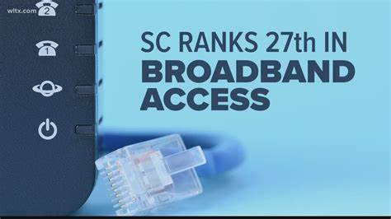
South Carolina received $185 million from the Treasury Department via its Capital Projects Fund and plans to use the entire amount for improving broadband access. More than 31,000 households and businesses are currently underserved or unserved across the state.
Telecompetitor 3/7/23
https://www.telecompetitor.com/south-carolina-will-use-its-entire-185m-capital-projects-fund-allocation-for-broadband/
Image credit:
https://media.wltx.com/assets/WLTX/images/cb55602b-e792-4e98-b9d8-14fede312dde/cb55602b-e792-4e98-b9d8-14fede312dde_1920x1080.jpg

