Sean Spicer Targets Own Staff in Leak Crackdown
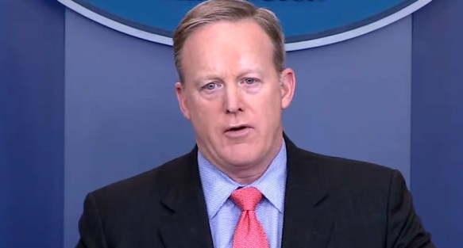
Press secretary Sean Spicer is cracking down on leaks coming out of the West Wing, with increased security measures that include random phone checks of White House staffers, overseen by White House attorneys.
Politico 2.26.17
http://www.politico.com/story/2017/02/sean-spicer-targets-own-staff-in-leak-crackdown-235413

