Self Becomes Latest Magazine to Turn the Page on Print
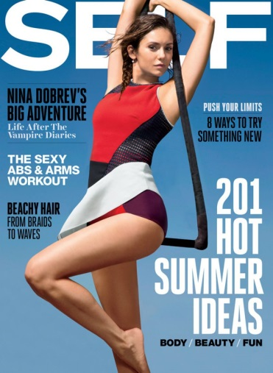
Self, the women’s fitness publication, will go online-only with its February issue. In so doing, it becomes the first of Condé Nast’s dozen or so major publications to cut its print edition entirely. Though overall circulation has been fairly steady, single-copy sales took a nasty hit, down more than 100,000 in the past two years, to 44,000.
MediaLife 12.5.16
http://www.medialifemagazine.com/self-latest-magazine-turn-page-print/

