Sen. Warner Demands FTC Action on Digital Ad Fraud
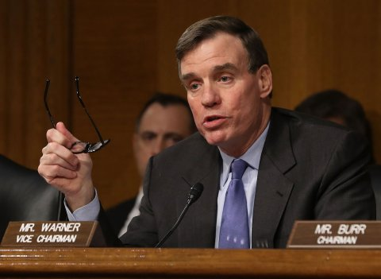
Sen. Mark Warner, D-Va., has written to the Federal Trade Commission demanding an investigation into digital ad fraud after revelations that Google Android apps had been involved in a large advertising fraud scheme. "I am writing to express my continued concern with the prevalence of digital advertising fraud, and in particular the inaction of major industry stakeholders in curbing these abuses," Warner states in the letter.
BuzzFeed News 10/25/18
https://www.buzzfeednews.com/article/craigsilverman/sen-mark-warner-is-pressing-the-ftc-to-tackle-digital-ad
Image credit:
http://static3.businessinsider.com/image/58b09ec2549057bc008b6ab7-480/sen-mark-warner.jpg

