Tech Firms Defend Child Safety Practices
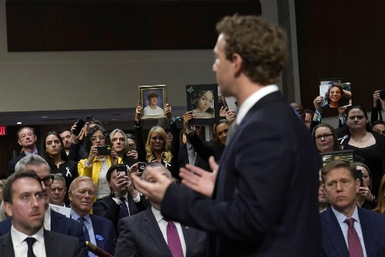
Members of the Senate Judiciary Committee criticized CEOs from Meta, Discord, Snap, TikTok and X, formerly Twitter, for failing to protect children online and vowed to resurrect stalled bills and launch new ones to protect kids from bullying, sexual content and other social ills. X CEO Linda Yaccarino and Snap CEO Evan Spiegel announced support for The Kids Online Safety Act, while the Meta, Discord and TikTok CEOs said they supported certain aspects of the bill.
Politico 1/31/24
https://www.politico.com/news/2024/01/31/senate-grills-zuckerberg-other-tech-ceos-on-kids-safety-failures-00138718
Image copyright:
https://bloximages.chicago2.vip.townnews.com/beatricedailysun.com/content/tncms/assets/v3/editorial/9/07/907290b7-ee4e-51d6-b010-0e94d32de1ed/65ba9651e1105.image.jpg?resize=1333%2C888

