Seven of the Top 12 Programs on Broadcast this Season are Unscripted
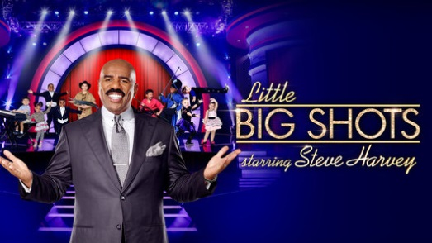
Remember a few years ago, when people were starting to write off reality shows? Long-running reality shows have, over the past few years, held up even better than many of the scripted shows on TV. And the recent launch of the new hit “Little Big Shots” proves there’s still juice left in the genre, if you can come up with a creative enough idea.
MediaLife 3.23.16
http://www.medialifemagazine.com/a-surprising-resurgence-for-reality-shows/

