Shonda Rhimes Just Delivered Over 1.3 Billion Hours of Streaming in Just Two Months
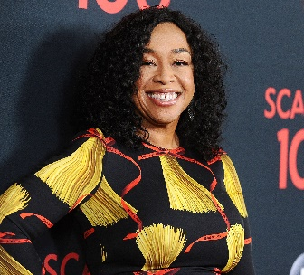
With Season 2 of her hit Netflix series Bridgerton capturing nearly 115.8 million viewing hours for the week of April 4-10, and now set to break Netflix's English-series debut mark set last year by the first season of the show, it's time to consider that creator/producer Shonda Rhimes just might be on the greatest roll in the history of video entertainment.
Next TV 4/12/22
https://www.nexttv.com/news/shonda-rhimes-just-delivered-over-13-billion-hours-of-streaming-in-two-months-netflix-global-top-10?utm_source=SmartBrief&utm_medium=email&utm_campaign=C74FC4FA-5D4D-4151-8915-3043BA411DBE&utm_content=58A77702-8147-4080-9C2F-A80E6BED753C&utm_term=a25693a1-51b6-4112-bde4-56bd420e983f
Image credit:
https://imagesvc.meredithcorp.io/v3/mm/image?url=https://static.onecms.io/wp-content/uploads/sites/14/2017/10/12/101217-shonda-rhimes.jpg

