Discovery Rolls Out Shoppable Showcase Ad Format
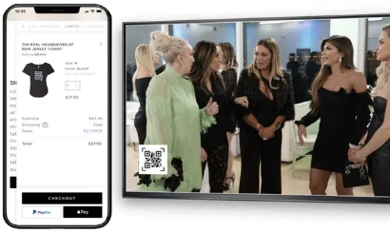
Discovery is rolling out new advertising tools for its Discovery+ streaming service and Discovery Go apps, including shoppable Showcase ads that align with its food and home show content and include QR codes that direct viewers to a site to purchase products. Other formats enable marketers to interact with viewers who have paused programming, lock in initial ad placement for all viewers or the break of a particular show, and deliver ads based on keywords appearing in programming.
Adweek 11/16/21
https://www.adweek.com/convergent-tv/discovery-rebrands-streaming-ad-format-offerings/

