Shrinking the Gulf Coast Dead Zone Part 1: Downriver
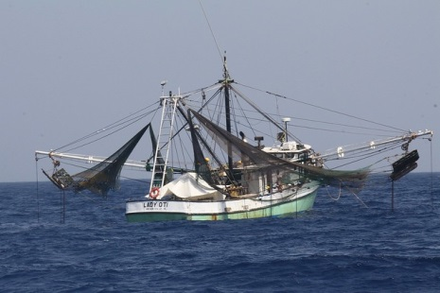
The Gulf of Mexico dead zone — a large, oxygen-deprived swath of water that is a result of nitrogen and phosphorus fertilizers from farms in the Midwest that have concentrated off the coast of Louisiana and Texas. The chemicals encourage the growth of algae, which suck up oxygen choking marine life. Escaping fish are forced to migrate out of natural habitats.
Pulitzer Center 9.6.19
https://pulitzercenter.org/reporting/shrinking-gulf-coast-dead-zone-part-1-downriver?utm_source=newsletter&utm_medium=email&utm_campaign=9102019
Image credit:
https://farm4.staticflickr.com/3825/9406759986_5f2e424d02_z.jpg

