Significant Digital Marketing Trends For 2022
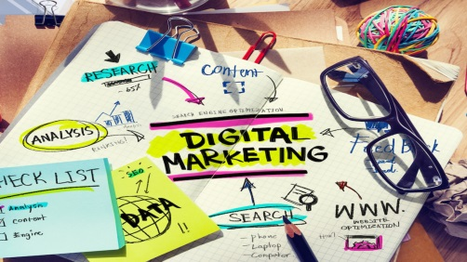
Main Street executive Phil Frost outlines six key digital marketing trends for 2022, including a shift toward delivering purposeful content to drive the "right [site] traffic" and a focus on the user experience rather than SEO tactics. Frost also predicts a rise in the use of short video formats on social platforms, more targeted influencer efforts, small business interest in hyperlocal marketing and increases in various types of promotional placements and creative formats.
Adweek 1/31/22
https://www.adweek.com/programmatic/2022-major-marketing-trends-across-seo-user-generated-video-ad-ops-and-influencers/
Image credit:
https://www.abcmoney.co.uk/wp-content/uploads/2017/07/what-is-digital-marketing.jpg

