Sinclair Adds 6 Neb. TV Stations Once Owned by Pappas
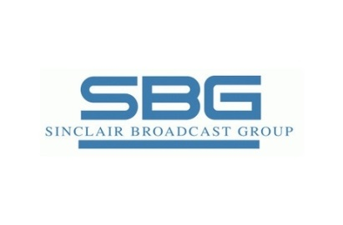
Sinclair Broadcast Group, via an auction of assets previously held by the bankrupt Pappas Telecasting, has acquired six Nebraska TV outlets for $31.25 million. Five of the stations are ABC affiliates, and the sixth is a Fox outlet.
TVNewsCheck 11/4/15
http://www.tvnewscheck.com/article/89752/sinclair-buys-six-pappas-stations-in-neb

