Sinclair to Acquire Tribune for $3.9B
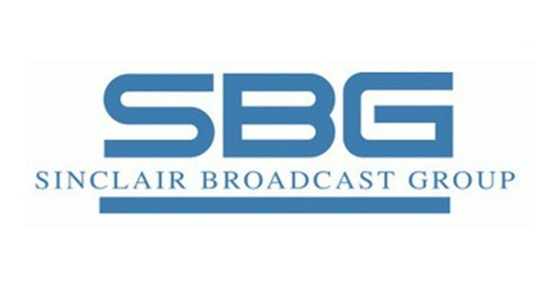
Sinclair has signed a $3.9 billion deal to acquire Tribune Media. In addition to acquiring Tribune's 42 stations, the deal opens up other opportunities, including digital platforms and advanced services for Next Gen TV, says Sinclair President and CEO Chris Ripley.
Broadcasting & Cable 5/8/17
http://www.broadcastingcable.com/news/local-tv/sinclair-inks-deal-buy-tribune-39b/165584

