Singapore Invokes 'Fake News' Law for First Time Over Facebook Post
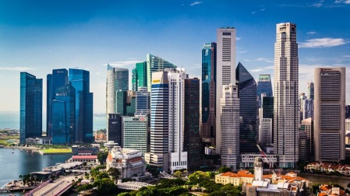
Singapore political figure Brad Bowyer on Monday corrected a Facebook post questioning the independence of state investment firms following a government request, in the first use of the country's new "fake news" law. Bowyer used "false and misleading" statements alleging the government influenced decisions made by state investors Temasek Holdings and GIC, according to a statement on the official government fact-checking website.
Reuters 11.25.19
http://news.trust.org/item/20191125050130-v7vpg/?utm_source=Pew+Research+Center&utm_source=Daily+Lab+email+list&utm_campaign=61b2d19c1b-dailylabemail3&utm_medium=email&utm_term=0_d68264fd5e-61b2d19c1b-396123901
Image credit:
https://www.lite1065.com/wp-content/uploads/sites/5/2019/10/singapore-iStock.jpg

