Sirius Setback for Flo & Eddie
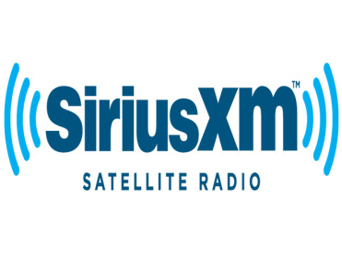
On Tuesday, New York’s highest appeals court ruled that companies like SiriusXM do not have to pay to play pre-1972 recordings. The court ruled that New York's common law doesn't protect the public performance of pre-1972 sound recordings.
RadioInk 12.21.16
http://radioink.com/2016/12/20/ny-court-shoots-pre-1972-song-case-sirius/?utm_source=ActiveCampaign&utm_medium=email&utm_content=Facebook+Enters+The+Audio+Space++Should+You+Worry%3F&utm_campaign=Wednesday+Facebook+launches

