Study: 81% of Smart Speaker Users Open to Ads
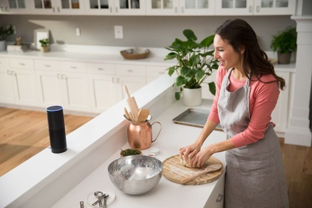
Fifty-nine percent of smart speaker owners say they don't mind encountering branded features or skills and 22% say they like them, a study by NPR and Edison Research has found. Ordering food, reviewing traffic and searching for recipes or getting other culinary advice are respondents' top three uses for smart speakers.
Marketing Land 7/20/18
https://marketingland.com/report-smart-speaker-ownership-driving-voice-adoption-on-smartphones-244709
Image credit:
https://images.vivintcdn.com/global/vivint.com/web/campaigns/articles/woman-using-amazon-echo-kitchen.jpg

