Interactive Smart Speaker Ads Spur Positive Emotions
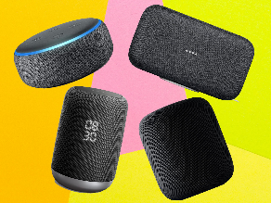
As the audio advertising market continues to grow, brands are not only investing in podcasts but in conversational smart speaker campaigns, which can drive a 24% increase in positive emotional responses from listeners, per research by Neuro-Insight, commissioned by Octave Audio, Say It Now and Xaxis. Pizza Hut and Tripadvisor recently ran interactive campaigns via Amazon Alexa, and Tripadvisor's Justin Reid predicts, "Having a presence on voice-activated devices is going to become as intrinsic as having a social media handle or website."
SmartBrief/Marketing 8.24.22
https://corp.smartbrief.com/original/2022/08/brands-experiment-audio-ad-interactivity?utm_source=brief
Image credit:
https://static.independent.co.uk/s3fs-public/thumbnails/image/2019/04/02/16/smart-speakers-hero.jpg

