Parks Data Shows 63% Of Internet Homes Own Smart TVs
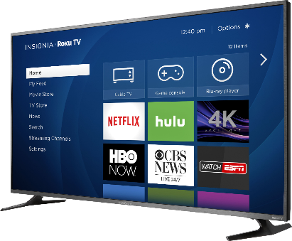
Smart TVs are in 63% of households with internet access, Parks Associates reports, compared with 38% in 2015. One benefit includes "more control of the data in the home," says company leader Elizabeth Parks.
MediaPost Communications (free registration) 1/16/23
https://www.mediapost.com/publications/article/381593/63-of-us-internet-homes-now-have-smart-tvs.html
image credit:
https://pisces.bbystatic.com/image2/BestBuy_US/images/products/5684/5684501ld.jpg

