Smartphone Features Start Spreading To Wearables
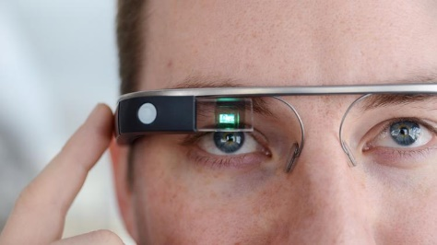
Tech companies are placing important smartphone features into other types of devices, such as smart watches, earbuds and glasses equipped with augmented reality technology. Any transition, Axios columnist Ina Fried notes, will face plenty of technical complications, legal questions and other hurdles.
Axios 7/2/21
https://www.axios.com/smartphone-breaking-up-esrbuds-glasses-watches-6c67ea9e-9f6f-413b-be52-6cca799d4811.html
Image credit:
http://media.bizj.us/view/img/1962491/google-glass-jim-carchidi*750xx900-506-0-44.jpg

