Smartphones Will Get 34% of Digital US Commerce in 2019
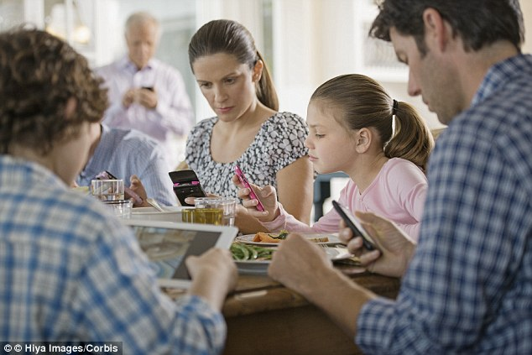
Commerce via smartphone is easily outstripping desktop and is on course to account for 34% of all digital sales in the US in 2019, eMarketer reports. The majority of smartphone owners will purchase one item or service, if not more, with their phones this year.
eMarketer 4/4/19
https://www.emarketer.com/content/smartphones-will-account-for-more-than-one-third-of-ecommerce-sales-in-2019
Image credit:
https://i.dailymail.co.uk/i/pix/2015/10/29/12/2DE860C500000578-3294994-image-a-28_1446120602130.jpg

