Like It or Not, Smartphones with Biometrics Will Soon Be the Norm
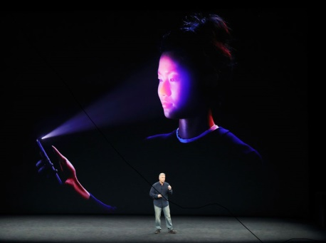
New research from Acuity Market Intelligence found that biometric technology will soon be ubiquitous on smartphones. The firm projects that nearly two-thirds of smartphones shipped worldwide this year will feature some sort of biometric capability. But it also estimates that by 2019, all smartphones worldwide will ship with biometric technology embedded in them.
eMarketer 9.14.17
https://www.emarketer.com/Article/Like-Not-Smartphones-with-Biometrics-Will-Soon-Norm/1016472?ecid=NL1009
Image source:
http://img.smartgoogly.com/uploads/2017/09/Apple-Iphone-X-Face-ID.jpg

