Snapple Turns To AI For Anniversary Campaign
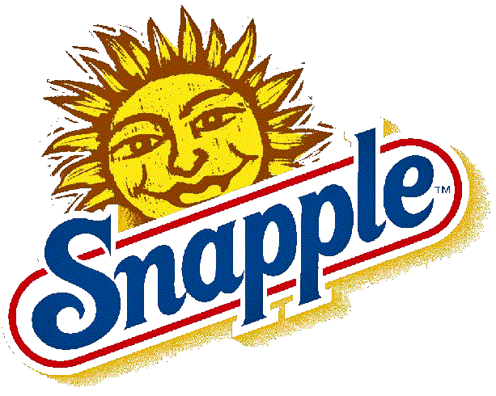
Keurig Dr Pepper's Snapple brand has launched the Snapple fAIct Generator campaign to commemorate 20 years of Real Facts appearing on Snapple bottle caps. Consumers can scan QR codes to access technology from OpenAI to generate facts on any subject for sharing on social media.
Packaging Europe (U.K.) 3/13/23
https://packagingeurope.com/news/snapple-drinks-brand-uses-ai-for-new-marketing-campaign/9515.article

