Social Audio: A Trend That's Likely to Last
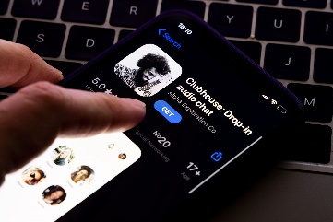
The fast-growing popularity of Clubhouse has spurred rival offerings from Facebook, Twitter and LinkedIn and the social audio trend looks like it has longevity, Amy Houston writes. Houston offers tips on how brands can authentically engage with social audio audiences through storytelling and urges marketers to consider diversity and accessibility in their efforts.
The Drum (free registration) 4/19/21
https://www.thedrum.com/opinion/2021/04/19/cutting-through-the-noise-the-social-media-audio-trend-here-stay
Image credit:
https://cdn.prdaily.com/wp-content/uploads/2021/04/clubhouse-social-media-tips.jpg

