Social Media Ad Spending Overtakes Print
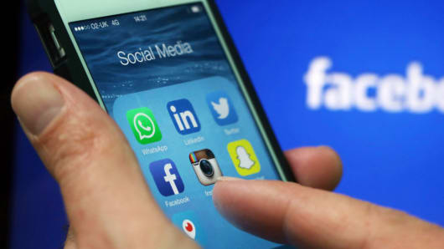
Ad spending on social media will increase 20% this year to $84 billion, Zenith reports, giving it a 13% piece of the total advertising market. This will be the first year that the category overtakes print, though it's still behind paid search and television, the marketing heavyweight.
Mobile Marketing Magazine 10/7/19
https://mobilemarketingmagazine.com/social-media-overtakes-print-ad-spend-expenditure-forecasts-zenith
Image credit:
http://fm.cnbc.com/applications/cnbc.com/resources/img/editorial/2016/07/29/103829912-GettyImages-473860564.530x298.jpg?v=1469802914

