Social Media Can Influence Children's Eating Habits
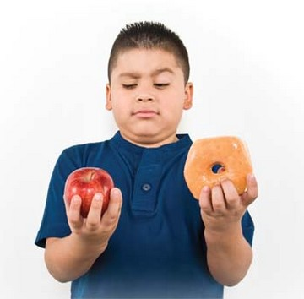
A research group found that social media can influence what and how much a child eats with a recent study of 176 children who were split into three groups and shown faux Instagram profiles featuring popular YouTubers eating either unhealthy food, healthy food or no food at all. Anna Coates and her team then offered the children an array of snacks and found that children who saw the unhealthy snacks posts consumed 32% more calories from unhealthy snacks and 26% more total calories than non-food-viewing children.
CBS News 3/4/19
https://www.cbsnews.com/news/social-media-influencers-may-sway-kids-to-eat-more-calories/
Image credit:
https://www.choc.org/wp/wp-content/uploads/2014/06/health-boy-obesity.jpg

