Social Media Giants Acknowledge Meddling
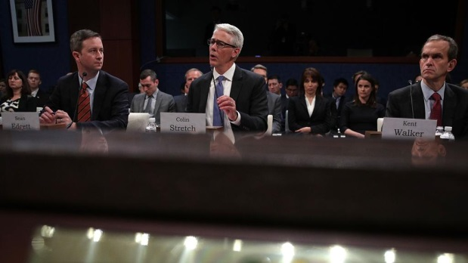
Facebook, Twitter and Google acknowledged that their platforms were used by Russia to try to create division over such disparate issues as immigration, gun control and politics.
Associated Press 11.2.17
http://www.tvnewscheck.com/article/108572/social-media-giants-acknowledge-meddling?utm_source=Listrak&utm_medium=Email&utm_term=Social+Media+Giants+Acknowledge+Meddling&utm_campaign=Hurricanes+Cost+Graham+%242.7M+In+3Q
Washington Post coverage (analysis) of the same issue
https://www.washingtonpost.com/news/the-fix/wp/2017/11/01/four-takeaways-from-the-senate-intelligence-hearing-with-facebook-twitter-and-google/?undefined=&utm_term=.7c665b79b75f&wpisrc=nl_politics&wpmm=1
Image credit:
http://www.italiaperme.com/wp-content/uploads/2017/11/HO14XLP2-kfPB-U1101812990467fiH-1024x57640LaStampa.it_.jpg

