Social Media Platforms Clamp Down on President Trump
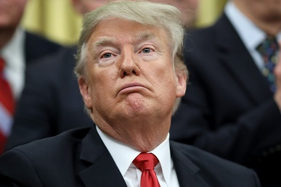
Facebook CEO Mark Zuckerberg says the risks associated with President Donald Trump's social media posts "are simply too great" and has extended its moratorium on his Facebook and Instagram postings through at least the inauguration of President-elect Joe Biden. Meanwhile, Snapchat locked the president's account with no reported end date, and YouTube is using a strike policy as part of a move to limit the president and others from posing videos with misleading election information.
The Verge 1.7.21
https://www.theverge.com/2021/1/7/22218876/youtube-trump-videos-election-results-misinformation-strike-removed
Image credit:
https://static.politico.com/fb/36/9cb4ca864149a4fffa2c7da8d929/190124-trump-gty-773.jpg

