Social Media Platforms Crack Down on Hate Speech
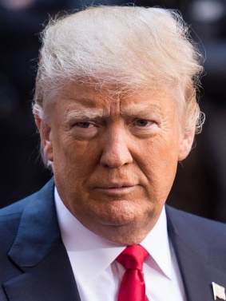
Social media platforms have taken increasing action against right-wing conspiracy groups and hate speech this week, shutting down channels and communities that violated their policies. Reddit disbanded some 2,000 of its forums -- including one promoting President Donald Trump -- for policy violations, YouTube shut down the channels of six well-known white supremacists and Amazon's Twitch imposed a temporary ban on Trump's channel.
Axios 6.30.20
https://www.axios.com/tech-finally-begins-a-crackdown-on-trump-cad9d517-9588-4db1-8d35-b570a5758404.html
Image credit:
http://cdn.iphonehacks.com/wp-content/uploads/2018/10/Donald-Trump2.jpg

