Social Media Spending Continues Rapid Growth in Q4
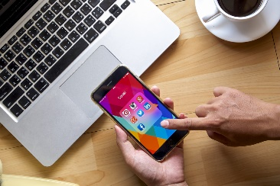
North American marketers boosted their fourth-quarter spending on social media advertising 92.3% year-over-year, reports Socialbakers. The addition of live shopping capabilities on platforms such as Facebook and TikTok helped show that livestreaming was a top priority, while influencer marketing dropped in Q4 by 17.6% compared to Q4 2019.
Marketing Dive 1/21/21
https://www.marketingdive.com/news/social-ad-spend-surged-over-holidays-with-video-content-commanding-spotlig/593682/
Image credit:
https://d187qskirji7ti.cloudfront.net/news/wp-content/uploads/2016/02/social-media-spending.jpg

