Some Harvey Reporters Also Rescuers
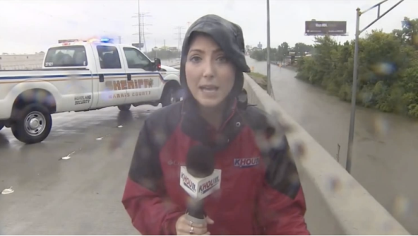
They've lifted people into boats, connected families through social media, flagged down rescuers and, in one case, coaxed people out of a flooding apartment house while on television. Most news reporters try to stay out of their stories, but say the dire situations they've seen because of Hurricane Harvey and its remnants left them no choice.
The Associated Press 8.31.17
http://www.tvnewscheck.com/article/106880/some-harvey-reporters-also-rescuers?utm_source=Listrak&utm_medium=Email&utm_term=Some+Harvey+Reporters+Also+Rescuers&utm_campaign=Some+Harvey+Reporters+Also+Rescuers
Image source:
http://www.oxygen.com/sites/nbcuoxygen/files/field_blog_image/2017/08/hurricane_harvey_reporter_saves_driver.png

